Consumer Behaviours

Student ID (digits)
Unit code
Department, Institution
Course
Professor
Date
Word count

Table of Contents
Identify the most important purchase you have made in the past six months. 3
The consumer decision-making process 3
Impact of communication sources, sociocultural and psychological influences on your buying behaviours 4
Impacts of communication sources 4
Socio cultural factors and the way they influence consumer buying 6
Psychological factors and the way they affect consumer buying 8
Suggestions on appropriate modification(s) on the marketing mix 9
APPENDIX 12
References 14

Identify the most important purchase you have made in the past six months.

Chow Mein has been one of my favourite dishes on my ordering menu. I always buy it for myself and for my little sister. The reason why I love it is that it’s well branded, well prepared giving it the best yummy taste ever. For the last six-month Chow Mein has been consistently been on my shopping list at least four times a week. It is also the best food for my little sister and whenever I go to do the shopping, I must make sure I place an order for and for me. Although Chow Mein is relatively expensive than other brands of foods related to it, its taste is exceptional and highly preferable for me. Most hotels and restaurants prepare it so well that you always develop the urge to consume more of it regularly. The dish is like thin noodles that have been made from corn and fine beans and are always accompanied by sliced meat, a medley of eggs, and well-prepared vegetables. I have developed a very big brand love for Chow Mein and I have not yet found another type of delicacy yummy than Chow Mein.

The consumer decision-making process
1 The awareness phase or the awareness phase.
This is the first step in the consumer's decision-making process. At this stage, this is where you realize that you need something and you must purchase it. In my case, the Chow Mein is always my favourite and my urge to buy it is always driven by two things; one by external stimuli where for quite some time I had seen many hotels advertising their meals on their websites and chow Mein has been one of the most advertised foods in many hotels websites which made me develop the urge to have a taste of it. Secondly, my love for chow Mein is driven by hunger and craving in many instances.
2 Searching for information on the desired product (research)
As soon as a consumer develops awareness or realizes that he needs a given item, what follows is the need to search for information on where he can get that product from. In my case, I most cases, when I develop the urge to eat chow Mein, I always look for the best hotels around me and order my meal from there. I always do this from the internet, and it gets delivered.
3 Evaluation or consideration of alternatives products that can be substituted.
At this stage, a consumer scales on several products in the market by comparing various parameters concerning various products in the market, which can be substituted to what he needs. At this point, the price and the quality of a product are always a priority (Stankevich, 2017). When I am doing my shopping, I always consider the price and the quality of what I need. After that evaluation, it's when I decide on what to buy.
4 The conversion or making of the Purchasing decision.
At this point, the consumer purchases his desired product and closes the deal by paying for the product that suits his needs better. This stage is always filled with convictions that what is purchased is the best.
5 Re-purchase or the post-purchase evaluation.
At this particular stage, the consumer always evaluates his purchasing decisions, the value of the purchased products, and if the product was good to him; he plans to purchase it once again and even recommend it to friends or families. See appendix on page 12

Impact of communication sources, sociocultural and psychological influences on your buying behaviours

Impacts of communication sources
Helping consumers create preference. As the seller of a product, the initial communication you make to a customer is crucial because it enables the customer first to be aware or recognize the need to use your product. This communication also helps the consumer differentiate your product from other brands in the market similar to your product. This move helps the consumer to create a preference for your product. When a seller adopts a good communication strategy with the consumers, it always convinces the consumers that your product is the best in the market arena (Reddy, 2017). Even after post-evaluation, those customers will always come back to purchase your product. This way, communication channels or sources used by the seller are very instrumental in influencing consumer buying behaviours.
Accountability: every business should establish a way of encouraging the consumers by creating strategic communication to provide feedback on the company's products. This move is supposed to demonstrate how accountable that business is to its consumers. For instance, a business can set up an online platform where consumers can leave their comments concerning several products offered by the business. Existing researches show that having this interactive communication with the customers makes the consumers feel valued, and in return, they tend to remain loyal to a given brand offered. Further, these communication sources always provide the consumers with the information they require concerning the certain product in the market. Many consumers make decisions to purchase given products based on the information given. Conclusively, a well-structured communication channel with well-detailed information on some given product has been proved to play a bigger part in influencing consumers' buying habits.

Personalization is one of the modern world factors that has been in use in influencing consumers' buying. What many companies do, they go into their databases and look for consumer buying patterns. They then do analysis and know what the consumer preferences are (Sadikoglu, 2017). After knowing the consumers' preferences, the company reaches the consumer through personalized communication, mostly through emails informing the consumer of any improvement on his preferred product. This move has been proved to influence most consumers to be prompted to buy more items.

Socio cultural factors and the way they influence consumer buying
Religion has been one of the identified social-cultural factors that affect consumer buying. According to the existing research, many consumers shy away from buying certain products in the market due to the religion they are affiliated with. For instance, Pork is mostly used by many Christians in the world. There are products which are made from pork which includes, sausages and smokies. These products are very yummy, but you find that Muslims cannot consume pork or any product affiliated with pork. This alone demonstrates that religion, a social-cultural factor, dictates to the people which products to consume and the ones not to consume.
Social status.: Societies in the modern world have been divided into three parts: the lower class, middle class, and the upper class that consists of the richest people in society—this division and disparity of income influences what each group consumes. For example, a high-class citizen has a higher likelihood of buying products with a very high price, while the low-class people will always buy products of low value. This shows that social factor and income distribution dictates or influences consumer behaviours of buying some items in the market.
Personality: We are all created differently; people's personalities and perceptions vary from one person to another in society. There are people in the society who are very rich, but you will find them consuming or buying products of low prices. Equally, there are still people in the society who are not rich, but you will always find them buying very expensive things. This demonstrates that people have got varied personalities, and these personalities implicate consumer buying.

Age: In society, we have different age groups. Interestingly, these age groups will always have different tastes in different things. First, we have the youthful groups; the youthful groups are always inclined to the modern or the upcoming things. You will always find the youths going for the latest phones in town, the latest cars, or even subscribing to the latest music in town. On the other hand, we have the other group which older people dominate. Although older people have got tastes, their tastes are so different from the youths' tastes. Now, here is the bottom line that age greatly affects tastes on what consumers choose to buy. The older people have their tastes on some given products and the younger people having their tastes on the other hand.
Occupation is another key social factor that influences consumers buying behaviours. In the world, there are thousands of occupations. In these occupations, there is the tool of work that is associated with each occupation. For example, a mechanical engineer will go for a spanner kit that contains testers, spanners, hammers, etc. A teacher will either go for a geometrical set, marker pens, or any product related to what a teacher does daily. This illustrates that the work that one does in society sometimes influences what he buys or what he spends on.
Economic situation: The economic status can be defined as his financial standing within a specific period. In people's lives, there are peak seasons or the boom seasons and the depression seasons. The peak season in a person's life is characterized by having good earnings in a given time. Depression time, on the other hand, is characterized by a time where the income earned is very low. Now, here is the point, when people have earned a lot of money in circulation, people tend to spend more buying goods or even services. Equally, when people have low incomes, they tend to spend less on their purchases. For instance, when tea farmers receive yearly bonuses, they are influenced to spend more on buying products.
Another example is when covid 19 emerged; many companies closed down. Many people became jobless; to survive with little savings, they were influenced to cut their spending on several items. This illustrates that economic status can affect consumers buying power.

Psychological factors and the way they affect consumer buying

Motivation: Human wants range from basic needs, security needs, self-actualization needs, etc. Of all these needs, security needs and basic needs are the most important. When a consumer is motivated sufficiently, there is a higher likelihood of influencing the consumer to buy more of that product. Many businesses, including supermarkets, give their customers coupons and discounts to motivate them to buy more from them or have a love for a given brand. Psychologically whenever clients want to purchase a product, they will only go for a product they know has an attached discount.
Perception: Most world companies invest a lot in advertising their products on various online platforms. The online advertisement develops consumers perception. Consumer perception can be defined as an instance where a consumer consolidates information concerning a given product, interprets it, and comes up with a meaningful image (Chen & Antonelli, 2020). When a customer has the picture of a given product behind his mind, he is prompted to develop a positive impression of that product. So, when he recognizes that he needs such a product, he will be prompted to buy that product he saw in an advert, of course, guided by the image in his head concerning the product. This way, consumer perception greatly influences the consumer to purchase the product. See Appendix on page 13
Learning: When a consumer consistently purchases a certain product, he is most likely to learn more of that product. The process of learning is developed over time. However, it's good to note that consumer learning is normally dependent on consumer knowledge and learning skills. In essence, we say that skill is typically acquired through practice, but knowledge is gained through experience. What happens a consumer can learn about a product through conditional or cognitive learning. In conditional learning, the consumer repeatedly encounters a product, which makes him develop a positive response towards it.
On the other hand, cognitive learning prompts a consumer to apply his skills and knowledge to derive a solution from the product he buys. When the consumer derives benefits from what he buys, he develops the urge to buy the product once more. This way, we say that learning can indeed influence consumer buying habits.
Attitudes and Beliefs: Beliefs and attitudes have also been identified to play a great role in influencing consumers to buy a given product. Based on what consumer hears about a product can influence one to buy a certain product. This belief and attitude are what marketers use to design marketing designs (Joshi & Rahman, 2019). To illustrate with an example, senior consumers of a commodity have many beliefs concerning a certain commodity they have used for a long time. Convinced by these beliefs, they are glued to buying that product because they think it gives a solution to their problems.

Suggestions on appropriate modification(s) on the marketing mix
On a lighter note, marketing mix refers to all factors controlled by businesses to influence consumers to buy their products. To modify the marketing mix, in this case, refers to ways that can be used to make the existing marketing mix better and sound. To appropriately answer this question, we will interrogate the 4Ps of marketing and find out what can be done to make them better.
Product
Product is typically the centre of every business. It is what the business offers to the consumers. Most businesses try to fulfil consumers' demands by offering consumers a better product. However, business owners should put into consideration the life cycle of a product. This involves having a track of every stage in making that product and having a standardized price for it. As an additional way of improving the product, the business should provide a forum to consumers to pick views on what is needed to be improved per consumers' needs (Wu, & Li, 2018). Once they do this, they can tailor the product towards customers' specifications, which will ensure that they will influence more customers to buy their products.
Price
The price of a product is another issue to consider in influencing consumers to purchase a product. Businesses must always be willing to collect market data on the perceived prices of their product in the market to gauge the willingness of the consumers to buy a product. Of course, while doing this, they should ensure that they give considerable discounts to the customers so that customers can be prompted to buy more of the product. However, they should also be cautious in giving discounts because it can also create an impression to the consumers that the product quality has been tampered with due to big discounts.
Place
Setting out a strategic place where consumers can access the product has always been every business goal. However, in the modern world dominated by technology, businesses should consider establishing online stores where consumers can get a pool of the products, they are interested in. This involves getting a way of making the product known and accessible to the final consumers. For example, companies like Alibaba and Jumia or amazon have virtual online stores that display what they have, and customers can choose what they want.
Promotion
Promotion refers to ways of making the product known to the public. Many businesses have been using print media like business cards as a way of advertising their products. In this era, a business should use the internet marketing platforms like Facebook, Instagram, LinkedIn, and Tik Tok to try and reach more people. Additionally, businesses should use public relations methods like celebrities to advertise their products because they influence a lot of people, which can guarantee high returns.

APPENDIX

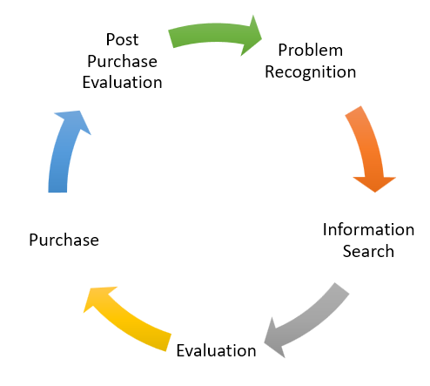
Perception
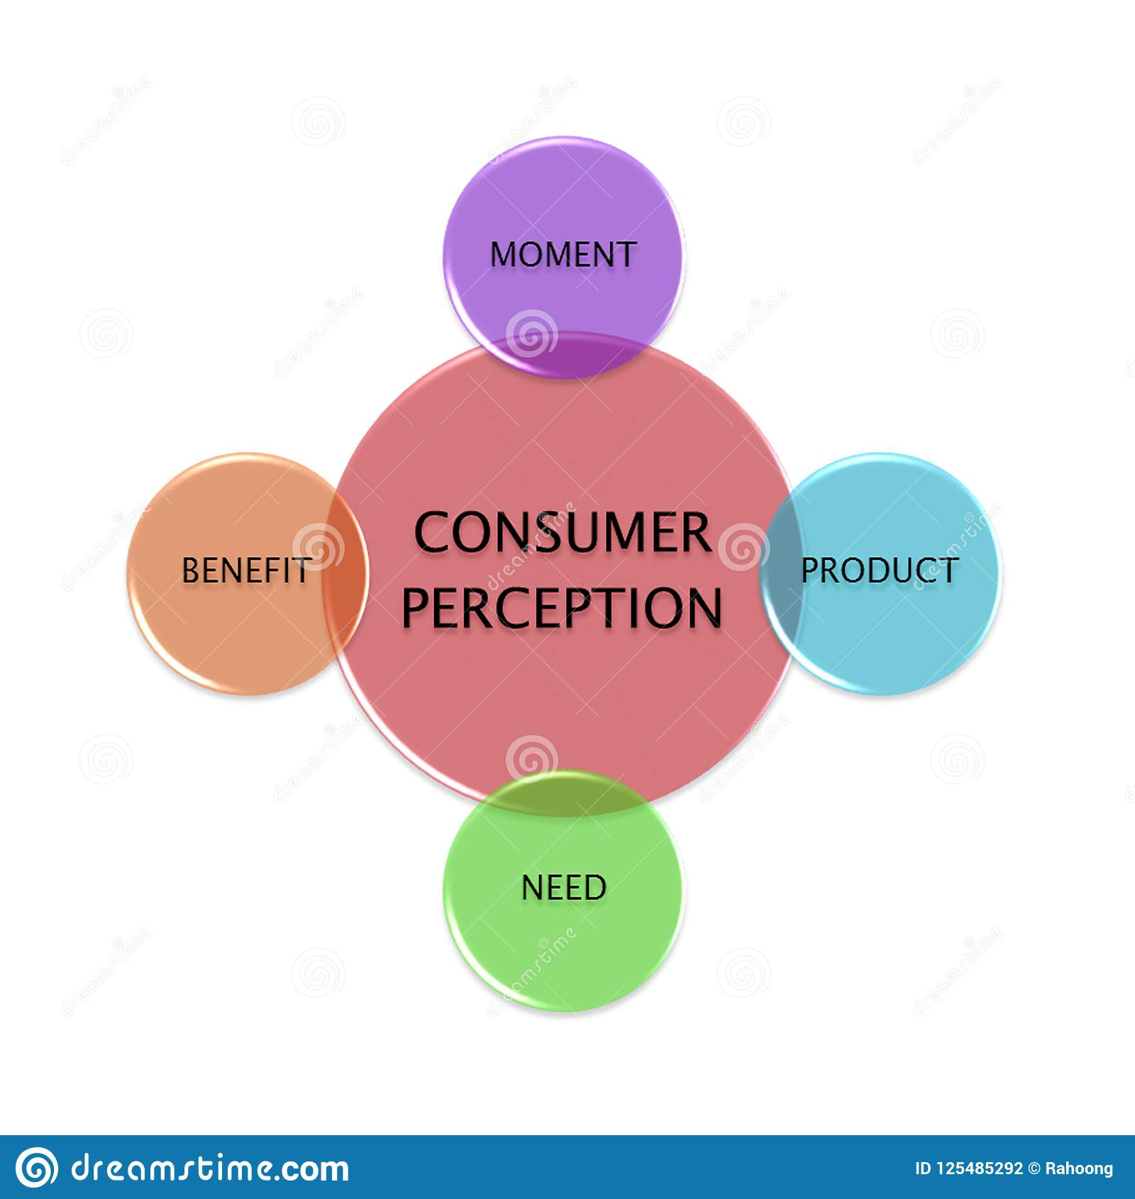

References

Chen, P. J., & Antonelli, M. (2020). Conceptual Models of Food Choice: Influential Factors Related to Foods, Individual Differences, and Society. Foods, 9(12), 1898.
Joshi, Y., & Rahman, Z. (2019). Consumers' sustainable purchase behaviour: Modeling the impact of psychological factors. Ecological economics, 159, 235-243.
Reddy, G. (2017). Digital marketing impact on the consumer decision making process in Nike's customer retail operations in South Africa (Doctoral dissertation, University of Pretoria).
Sadikoglu, G. (2017). Modeling of consumer buying behaviour using Z-number concept. Intelligent Automation & Soft Computing, 1-5.
Stankevich, A. (2017). Explaining the consumer decision-making process: Critical literature review. Journal of International Business Research and Marketing, 2(6).
Wu, Y. L., & Li, E. Y. (2018). Marketing mix, customer value, and customer loyalty in social commerce: A stimulus-organism-response perspective. Internet Research.

